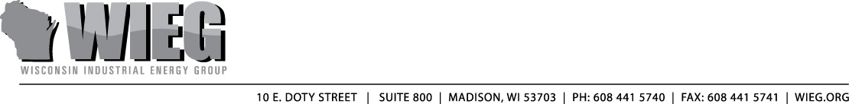

To: Assembly Committee on Jobs, the Economy and Small Business

From: Todd Stuart, Executive Director
Wisconsin Industrial Energy Group, Inc.

Re: Assembly Substitute Amendment 1 to AB 755 (LRB 0313/1)

Date: March 2, 2010

Your committee is scheduled for an executive session today on Assembly Bill 755. Based upon our preliminary review of the substitute amendment to AB 755 (LRB 0313/1) the Wisconsin Industrial Energy Group (WIEG) appreciates many of the changes made to address our concerns with the original bill. However, WIEG remains opposed to this legislation.

WIEG recognizes the efforts made by the authors to address our initial concerns. In particular, we truly appreciate the changes made to provide some checks & balances on the overall funding of the new efficiency programs and also the language to prevent utility “double dipping.”

Our first major concern with the substitute amendment is its potential to disrupt the business programs currently administered by Focus on Energy, Shared Savings and/or industrial self-directed programs. WIEG fears the language (page 5, section 11, lines 10 – 21) could potentially add administration, duplication and new costs. Industrial self-directed programs were created in 2005 Act 141 with the intent of an easy-to-use, customer-friendly program for large and sophisticated businesses. The companies WIEG represents are complex operations that must maintain confidential information and customized systems. WIEG is concerned that the Contractors provisions in the substitute will both increase program costs and limit members’ access to the specialized talent that is required for their business operations.

One remedy for this concern may be to expressly limit the scope of this section of the substitute only to energy efficiency & renewable resource programs funded through federal and state grants and/or to the new voluntary utility program created in the legislation.

Our other major concern has new language (page 7, section 15, lines 1 – 4) that earmarks 10 percent of ratepayer money collected for energy efficiency, conservation and renewables programs and transfers it to the DWD. $166 million in ratepayer funds have already been transferred to the state for budget balancing purposes, and one of the major objectives of Act 141 was intended to put an end to those diversions. This concern would be eliminated simply by deleting this new language.

There are a number of areas in the amendment that we believe have been improved over the original bill, but could potentially use more refinement. Here are some key areas that we would urge the committee to take a very close look at before voting to approve this bill:
- terms & conditions for customer billing
- the definition of “cost effectiveness”
- utilities earning a return on efficiency

In summary, industrial customers are still reviewing the implications of this language. However, as currently drafted, WIEG has serious concerns that the substitute could disrupt of current energy efficiency programs designed for industrial customers. WIEG also strongly objects to ratepayer funds once again getting transferred to the state’s coffers.

WIEG appreciates the intent behind this legislation and is willing to work with the authors and this committee to help address some of the concerns it has identified here. Thank you very much for your time and consideration.

